ENGR421 – HW3 REPORT

BERK BAHADIR BAHCETEPE

0071533

For this homework, I started with the generation of the data with the required values. I generated random samples from 3 different classes. Then, I wrote this data to a csv file and called them back. Later, I plotted the data points to visualize the data. I assigned first 2 columns to X and the last column to y since these data points were bivariate (has two features) and y column contains the labels of them. In order to make calculations and fit the sizes, I used the one-of-K encoding shown in the previous lab section. With this, I obtained the labels in the form of 1 0 0, 0 1 0, 0 0 1. Later, I defined the sigmoid function and the gradients. During the calculation of the gradients, I took the error function, subtracted y_predicted with the sigmoid function and took the derivative of it with respect to the parameters such as W and w0. The calculations I have made are shown in Fig.1. After calculating the gradient functions, I initialized the w and w0 parameters and applied a gradient decent technique and update the until they reached to the desired value (np.sqrt(np.sum((w0 - w0_old))**2 + np.sum((W - W_old)**2)) < epsilon). I have reached to the approximately accurate values of parameters after 2020 iterations and plotted the objective function during these iterations. Finally, I calculated the confusion matrix and realized that my algorithm has made only 4 mistakes and in order to detect those mistakes I drew the discrimination lines (boundaries) which shows the area of each class. The 4 data points that are misclassified are detected.

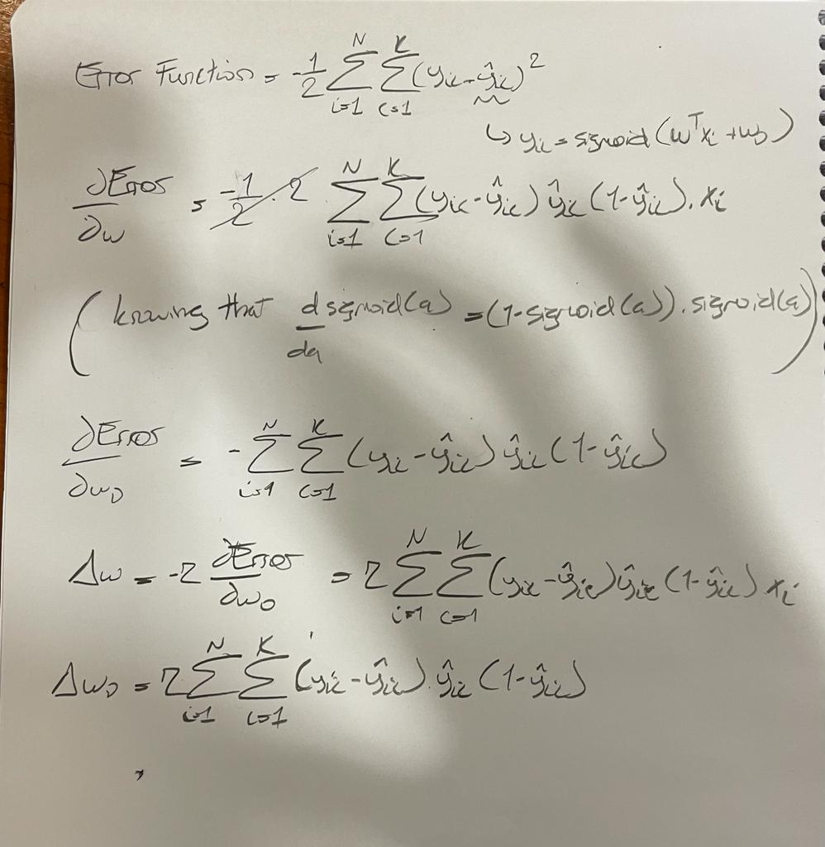

*Fig.1. The derivations of the gradient and update functions*

*Fig.2. Decision boundries for each class*

*Fig.3. Objective function throughout the iterations*

*Fig.1. Confusion matrix*